January 19, 2000

MANAGERS, OPERATIONS SUPPORT (AREA)

SUBJECT: National Periodicals Processing Standard Operating Procedures (SOP)

By now, you and your staff have had the opportunity to review the draft of a national Periodicals Processing Standard Operating Procedure (SOP) and forward your comments. All of your concerns were reviewed; changes were made. Now it is time for field implementation.

Attached is the national SOP for processing Periodicals, the next step in the effort to intensify our service improvement plans. Improved placarding, proper Area Distribution Center (ADC) make-up, and no commingling with other mail classes are some of the fundamental components emphasized in this SOP. The document also points out area responsibilities for monitoring the compliance and efficiency of transportation routings, operating plans, and distribution hubs.

While not specifically defined in the SOP, it is important that areas continue to track plant conditions and determine the cause of any major delays, then surface systemic issues to headquarters. Processing Operations will continue to facilitate the resolution of system problems and will work with you to meet our customers’ expectations.

Please forward this SOP to your field units for immediate implementation. Your cooperation throughout this endeavor is appreciated. If you have questions or concerns, please contact Joe DiPietropolo in Processing Operations at (202) 268-4448.

Nicholas F. Barranca

Attachment

cc: Mr. Black
Mr. Rapp
Mr. Moden
Mr. O’Tormey
Mr. Pajunas
Mr. Spates
bcc: Mr. Goldstein
Mr. Dipietropolo
Ms. Gallagher

STANDARD OPERATING PROCEDURES (SOP)

FOR PERIODICALS PROCESSING

INTRODUCTION

Purpose

This document establishes some minimum requirements and procedures for the processing of Periodicals that will strengthen our corporate service improvement effort for this important class of mail. These operating procedures will support our corporate goal of providing our customers with a competitively priced product that provides reliable and consistent service.

Scope

The Postal Service, in association with the Mailers’ Technical Advisory Committee (MTAC), has spent the last few years reviewing all aspects of the acceptance, processing, and transportation of Periodicals. Their findings included the identification of many problem areas. Some of the problems were systemic in nature and required headquarters’ intervention. Other problems could be easily improved through local initiatives. These guidelines are the first step in a series of actions that will be incorporated in the procedures for the handling of Periodicals. In addition, these guidelines and procedures are being developed to establish a more service responsive distribution network for Periodicals. This document will specifically relate to:

- Minimum requirements for the processing and distribution of Periodicals within the Processing and Distribution Centers/Facilities (P&DCs/Fs).
- No commingling of Periodicals with other classes of mail.
- Labeling requirements for minor containers (e.g. sacks, trays, tubs).
- Placarding requirements for major containers (e.g. pallets, APCs, BMCs, hampers, wiretainers, postal paks, gaylords).
- Suggested performance targets and service indicators.
- Training of supervisory and craft employees.

Background

Previous endeavors on improving Periodicals’ processes revealed some universal systemic problems. To address these problems, John Rapp, Vice President, Field Operations Support, established a headquarters Periodicals Process Management Review Team to identify root causes of poor service and begin a process towards resolving them. To that end, the development of this SOP will assist managers in the field with standardizing the handling and identification of Periodicals.

Process Management

Philosophy and Acceptance

The Postal Service corporately has integrated the process management philosophy at the national level and is encouraging field units to use the method in all aspects of our core business processes that relate to customer satisfaction. Process management is a proven data driven tool for problem solving. The drilling down and questioning “WHY” to identify fundamental problems is a practice that should be incorporated into our daily decision making processes. One important element of the process management is the support and acceptance of local management.

Process Management Teams

Headquarters has requested that every cluster establish a process management team for Periodicals. These teams should be the vehicle to establish (or review) a Periodicals’ processing strategy and to implement, monitor, and adjust as conditions warrant. Any issues not solvable at the local level will be forwarded to the area Periodicals coordinator for review and action.

Processing Mailflow Map

A plant process map should be developed in order to identify the present mailflow and operations process indicators that can be used to flag problems in upstream operations. After validating these maps, appropriate changes should be made to maintain an efficient distribution network through the plant and the make-up of a product that is more service responsive to the downstream operations. The operations process indicators should be monitored to identify recurring issues or failures between internal operations of a plant.

These process maps could provide operational assistance and aid in the analysis for cost reductions, staffing requirements, and training.

PLANT OPERATIONS

Operating Plan

The facility operating plan is used to schedule or plan efficiently the processing and distribution of mail from receipt at the originating dock operation to the destinating dock dispatching operation. The plan provides an organized and standardized format to move mail from one processing operation to the next, taking into consideration the facility equipment, capacity, and transportation. The operating plan treats all mail by class and service standard commitments. The elements of the operating plan are as follows:
Mail Arrival Profile
Average Daily Volumes
Planned Start Time
Critical Entry Time
Clearance Time

The operating plan must treat Periodicals similar to First-Class Mail having a clearance time on day-zero to meet dispatches of value (DOVs) for outbound transportation at origin and DOVs to delivery units at destination. For the purpose of this document, day-zero refers to the day of the operating plan and is normally from 0700 to 0700 on day of receipt. The processing of Periodicals must be accomplished concurrently with First-Class Mail, but cannot be commingled with any other class of mail. The only exception is at the carrier route level.

Hub/Centralized Operations

This day-zero clearance time must also be considered when the origin facility performs no processing for originating Periodicals but acts as a transfer point to another plant or BMC which provides the outgoing processing and dispatching for a number of smaller facilities. All operating plans must reflect dock clearance time that will allow the Hub/centralized facility adequate time for processing and timely dispatch of all Periodicals. This clearance time must guarantee meeting all DOVs for outbound transportation.

Note: The Hub/centralized facility operating plan must be developed to be service responsive.
The Hub/centralized facilities’ critical entry time must reflect the smaller facilities volumes as its originating mail.

Recommended Entry Times and Local Agreements

While the operating plan is the official blueprint for processing mail, plants may enter local agreements. These may include recommended entry times that would prompt Periodical mailers to enter mail at optimum times when sufficient staffing and processing capacities exist. Mail entered under local agreements still must adhere to the operating plan clearance time (CT).

Responsibilities

Area Distribution Networks (DN)

The area DN office will review all plant transportation requirements for each operating plan change request to ensure that the changes or revisions can be implemented with valid and adequate transportation. Effective with the issuance of this document, each area DN office must review all transportation and update all National Air and Surface System (NASS) products to ensure service responsive routings are provided to every plant with outbound Periodicals. The area DN office has the authority to designate where mixed (jackpotted) mail will be routed.

Manager of In-Plant Support

The Manager of In-Plant Support must ensure that the operating plan is updated, reflecting all changes in processing in an effort to improve service for Periodicals. These changes would include operations in annexes and/or Hub operations.

Transportation Manager

Local Transportation Managers will ensure that all routing for transportation carrying Periodical Mail is correct and service responsive. Transportation that is not according to NASS schedules should be updated. Placards should reflect NASS schedules and routings, showing each leg of transportation and/or transfers.

ACCEPTANCE PROCEDURES

All acceptance personnel should be trained in the acceptance of Periodical Mail, and at a minimum, receive the latest training, “Getting Closer to the Mailbox.”

All Periodicals’ mailings must be verified for proper makeup and accurate labeling. Acceptance personnel must ensure mailers use the most current labeling lists. Makeup and revenue documents must be verified for accuracy and completeness. If applicable, Coding Accuracy Support System (CASS) certification documents should be provided for compliance to the DMM. In an effort to improve service and customer satisfaction, BMEU personnel should provide feedback to the mailer and the owner of the mailing on all discrepancies found during the verification process. Upon completion of the verification, the BMEU can release direct containers for staging and/or dispatch. Acceptance personnel at plantload operations should keep the local P&DC/P&DF informed of volume and transportation information.

PLANT OPERATIONS for ORIGINATING PERIODICALS

P&DC Platform

Once an acceptance unit has released a Periodicals’ mailing to mail processing, platform personnel must apply dispatch/routing placards, showing minimum requirements (see attached placard),. to mail transport equipment (MTE). The originating P&DC is required to process working or mixed volumes. Platform personnel must attach an in-house placard to these volumes and route the Periodicals to the appropriate operation for distribution. If the facility does not process working or mixed volumes, then the MTE should be placarded as working Periodicals and transferred to the HUB/centralized operations.

Additionally, Periodicals may arrive on Highway Contract Routes (HCRs) from smaller P&DCs or P&DFs or Associate Offices or on Motor Vehicle Services (MVS) from stations and branches with acceptance units. The next handling will be determined based on the information located on placarded containers or labels in sacks or trays. A facility that acts as a dock transfer and does not process originating Periodicals must still placard for transportation. If this facility is required to process originating Periodicals, then placard for in-house processing and transport to proper primary breakdown unit. The origin office must not commingle Periodicals with other classes of mail.

Sack or Tray Break-Up Operation—Originating (Sack Sorter/Manual Operation)

Originating trays or sacks must be sorted to Area Distribution Center (ADC) separations. Containerization and dispatching should be completed to the fullest extent possible by each origin plant. At a minimum, a P&DC must build containers for all overnight offices, any direct transportation, and whatever other destinations the volume warrants. The remaining lower volume ADCs may be jackpotted and transferred to a HUB, HASP, or BMC operation for break-up and transportation. This jackpot container should be made up only at the direction of the area office. Identify a direct container with a routing placard and dispatch; identify a mixed container with a placard indicating mixed Periodicals.

Mixed Sacks and Trays—Originating (SPBS/Rack Operation)

Dump mixed sacks and trays and distribute direct bundles or rolls to ADC separations (minimum requirement). Label ADC trays and/or sacks and transport to sack and tray break-up operation for dispatch. The origin office must not commingle Periodicals with other classes of mail. Separate mixed working bundles to downstream operations:

Machinable
- Flats
Flat Sorter Operation FSM 881/1000
- Letters
Automation
Non-Machinable
- Manual Operations Flats/Letters

NOTE: Polywrapped Flats should be considered machinable.

Open and distribute mixed working bundles to ADC separations (minimum requirement). Ensure correct labeling of all ADC trays, tubs, and sacks; then transport to sack and tray break-up operation for dispatch. Local residue separations should flow to downstream operations for distribution. Placard local residue for appropriate downstream operations showing day of delivery.

Note: Clearance times for all originating Periodicals received by a plants’ critical entry time should be on day zero.

PLANT OPERATIONS for DESTINATING (INCOMING) PERIODICALS

P&DC Platform

Incoming Periodicals will be received at P&DC or P&DF platforms from mailers, from BMCs and from other P&DCs for distribution in the Zip Code area designated for their local delivery. Platform personnel should verify contents of arriving vehicles and enter vehicle information into TIMES.

All Periodicals transported by the mailer must have a PS Form 8125, PVDS Verification and Clearance. After checking the integrity of the mail load to be sure that it is safe to unload, platform personnel must compare the shipment with the form for class, number of containers, and processing category. If the 8125 is properly completed and the information on it matches the mail, the “Destination” section must be filled out. Note any load condition irregularities in the “Comment” section.

Give unloading preference to vehicles containing a periodicals’ mailing. Periodicals can arrive palletized, sacked, bundled, or trayed and can be sorted by ADC, 3-digit SCF, and/or 5-digit direct. During the unloading procedures, platform personnel must read placards and labels to determine the proper destination for each particular container being unloaded. If the container is a direct 5-digit and requires no additional sortation, then it should be transported to the appropriate dispatch bay. If the container requires in-house processing, then transport it to the appropriate staging/processing operation. If the container is an ADC and/or 3-digit working container, then transport to the appropriate break-up area.
Machinable
- SPBS/Manual Break-up
Non-Machinable
- Manual Break-up

Note: Platform signage should indicate which zones will require additional distribution.

Break-up Operations
Based on the equipment at the P&DC/P&DF, most ADC and/or 3-digit working containers will be separated by machinable and non-machinable. Incoming Periodicals must not be commingled with other classes of mail in break-up operations.

Sacks and Bundles
Machinable (SPBS Operation)—Containerized machinable bundles and sacks should be dumped at the SPBS and distributed. Separations for 3-digit letters and flats and 5-digit letters and flats, not requiring additional in-house distribution, should be placarded and transported to the dispatch platform. For zones that require secondary distribution in-house, a separation should be made by zone, and by letters and flats. Each container should be identified for next handling with appropriate placards and transported to the appropriate downstream operation.

Non-machinable (Manual Break-up Operation)—Containerized non-machinable bundles and culls from the SPBS operation should be processed in the manual break-up area. Separations for 3-digit letters and flats and 5-digit letters and flats not requiring additional in-house distribution should be placarded and transported to the dispatch platform. For zones that require secondary distribution in-house a separation should be made by zone, and by letters or flats. Each container should be identified for next handling with appropriate placards and transported to the downstream operation. If the facility does not have an SPBS for the distribution of machinable Periodicals, then the manual break-up would be used for machinable mail also.

Letters – Incoming Periodicals should be separated by automated barcoded, automated non-barcoded, and manual.

Automated barcoded - Create a DBCS sort plan to maximize the finalization of non-automated zones. These zones should be trayed, labeled, and placarded for transport to the tray break-up operation for dispatch. All automated secondary directs should be trayed, labeled, and placarded for merging in with barcoded secondary DPS letter operations. All residued letters from the OCR run should be merged with this run on the DBCS. Commingling of Periodicals may be permitted at the DPS level.

Automated non-barcoded
Incoming Periodicals must not be commingled with other classes of mail in OCR operations. An OCR sort plan should be created to maximize the finalization of non-automated zones on the OCR. These zones should be trayed, labeled, and placarded for transport to the tray break-up operation for dispatch. All automated secondary directs should be trayed, labeled, and placarded for merging in with barcoded First-Class Mail secondary letters operations. All residued letters should be labeled for barcoded primary Periodicals letters operations.

Manual letters
Incoming Periodicals must not be commingled with other classes of mail in primary manual operations. Create a primary distribution case design that would maximize the finalization of non-secondary AOs and city zones. These zones should be trayed, labeled, and placarded for transport to a break-up operation for sortation and dispatch. In-house secondary zones should be trayed, labeled, and placarded for break-up operations to zones.

Manual secondary sortation of Periodicals can be merged with First Class Mail to the carrier route. Proper identification as “First-Class Mail” must occur when Periodicals are commingled at the carrier route level.

Flats-Incoming Periodicals
Automated Flats—(FSM 881 BCR/OCR).. With today’s technology we are able to operate the FSM 881 as an OCR and BCS in a mixed environment, which benefits the Periodicals network by enabling us to save handlings on preparation and expanding the run time for this class of mail. Incoming Periodicals must not be commingled with other classes of mail in primary operations. Create primary flat sort plans at the ADC/SCF/CITY level to maximize the finalization of non-automated secondary zones. These direct zones should be labeled, placarded and transported to break-up operations for dispatch. All in-house automated secondary zones should be labeled and sent to break-up operations for separation by zone and merging into secondary distribution. All in-house manual secondary zones should be labeled and separated by zone for manual secondary distribution. All non-reads from the automated primary should be labeled and placarded for distribution on FSM 881 keying. The FSM 1000 should accommodate Periodicals volume that was deemed oversized for the FSM 881 and any culls from the FSM 881. Any Periodicals processed on the FSM 1000 should be labeled and placarded in the same manner described above. In the future, the AFSM 100 will have the ability to support all FSM 881 volumes and a portion of the volumes designated today for the FSM 1000.

NOTE: Polywrapped Flats should be considered machinable.

Automated Secondary—(FSM 881 BCR/OCR). When volume permits, Periodicals will be kept pure and labeled and placarded appropriately. If volume or time is not warranted, commingling of Periodicals is permitted at the carrier route level with First Class Mail only. At no point in the distribution cycle should Periodical flats be worked with Standard Mail (A) flats.

Manual Secondary. When volume permits, Periodicals will be kept pure to ensure flexibility at the carrier unit; this volume will be labeled and placarded appropriately. If volume or time is not warranted commingling of Periodicals is permitted at the carrier route level with First Class Mail only. Proper identification of flats as “First-Class Mail” must occur when Periodicals are commingled at the carrier route level

LABELING

General Information

Labels have always played an important role in the USPS. They are to containers as addresses are to letters. In recent years, labels have evolved to become information rich. The readability of labels is growing ever more important in transporting our products within our plants and from coast to coast.

Label Sources

- Mailer applied sack, tray, and pallet labels.
Must be verified at origin office during acceptance for accuracy and readability.

- Topeka Label Printing Center.
Quality procedures must be put in place to verify readability.

- Local USPS On-Demand Label Printer Systems (uses SPS via Passport System).
Quality procedures must be put in place for Maintenance to perform readability tests as routine preventive maintenance.

Labeling Requirements

Mailer applied labels must follow the regulations in the DMM. Postal applied labels will be pink for Periodicals and follow the make-up requirements of the latest labeling list issued by Headquarters and disseminated by the area offices.

Labeling Procedures

All minor containers (e.g. sacks, trays, tubs) that will be dispatched out of the facility should be labeled with pink labels. These labels must follow DMM standards for label content. For example, on Line 2, “NEWS” would be printed for publications issued weekly or more frequently, while “PER” would be used for all other publications.

In-house minor containers should be labeled with pink labels showing the contents as Periodicals and the next handling destination. For TMS sites, these labels must be printed using On Demand Label Printers or ordered from Topeka to ensure accurate flows throughout the facility. Non-TMS sites can design labels locally.

PLACARDING

All major containers for dispatch out of the facility will be required to use the format as described in this documentation including the use of PINK paper. This new placard design allows the designating site to remove the bottom portion for comments or discrepancies and return to the originating site. This immediate feedback mechanism will facilitate a quicker response time in identifying and correcting deficiencies, both in content and routing. It also gives to the designating facility the option to notify the originating site by phone, mail, or email.

In-house major containers should be placarded at a minimum, with the contents and next handling designation, date, and clearance day. The color of the in-house placard must be hot pink (See attachment).

SERVICE STANDARDS

Service commitments for Periodicals are measured from point of entry to delivery to the customer based on the origin and destination 3-digit zip (SCF) codes. These commitments range from 1-7 days depending on the entry point. The most important factor for a processing employee to understand when handling Periodicals is that from receipt at the dock to dispatch from the dock, you must clear all Periodical volumes on Day Zero regardless of origin or destination. To say it another way, all Periodicals received by critical entry time must be dispatched on the next available transportation.

Note: Signage should be developed to communicate these service requirements.

Service Indicators

Today, the Daily Mail Condition Reporting System (MCRS) will serve as one of the indicators used to assess the performance of Periodicals processing. The specific indicator in the MCRS will be Delayed Periodicals, Line Number 7 Outgoing Periodicals and Line Number 19, Incoming Periodicals.

Entry Schedule for Periodicals (ESP) is a future enhancement that will provide a measurement indicator that considers arrival, unload, and delivery of Periodicals. This system is dependent on mailer seeding procedures.

A tracking system to monitor customer complaints will be activated. This will enable trends to be developed regarding our customers’ perception of our handling of Periodicals.

TRAINING

Each district and P&DC/P&DF should ensure that every acceptance clerk has received the recently developed training for Periodicals. “Getting Closer to the Mailbox” is a four-hour training module focused on how to prepare Periodicals, both from a cost and processing standpoint.
Operations’ training for Periodicals (course #51501) is available for delivery and mail processing employees. Two separate training packages were developed for managers/supervisors and craft employees. The one-hour video, “Delivering the Promise – On Time Delivery for Periodicals Mail”, is divided into three segments which must be viewed by all operations employees.

Instructions on Use of Periodicals’ Placards

The placard attached and depicted below illustrates an example of the EXTERNAL placard that will be used to dispatch Periodicals to destinating offices. EXTERNAL placards will use light pink paper and follow the format provided on the sample.

The origin office must
- Print the Destinating ADC; contents of container; ZIP range.
- Indicate the mode of transportation.
- Complete all legs of Routing Information.
- Record Dispatch Date and Service Commitment.
- Include the name/phone number of a contact person to whom container irregularities can be reported.

The destinating office must
1. Record Date of Receipt and note date of service commitment
2. Provide feedback on irregularities by tearing off the bottom portion of the placard, showing Origin Office. Complete the name of person reporting the irregularity, the nature of irregularity.

Note: The small number 327 on the tear-off portion indicates to the Origin Office the ID of the destinating office if not indicated in the irregularities.

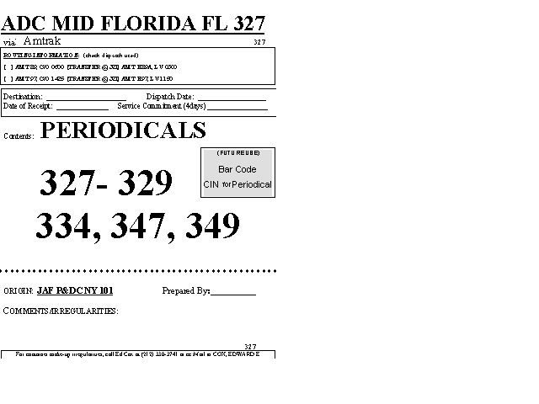

Instructions on Use of Periodicals’ Placards

The placards attached and depicted below illustrate two examples of the INTERNAL placard that must be used to distribute Periodicals within the plant.

INTERNAL (or in-house) placards must be printed on hot pink paper to denote Periodicals and not to be misconstrued as the color code used for SATURDAY delivery.

EVERY container identified on the dock that will require distribution or break-up must be placarded with this type placard and transported to the appropriate operation.

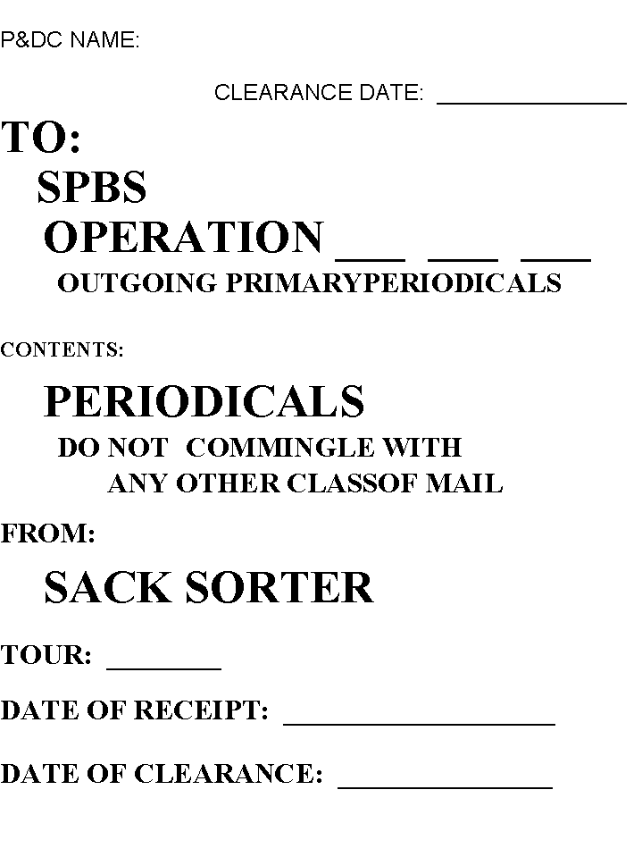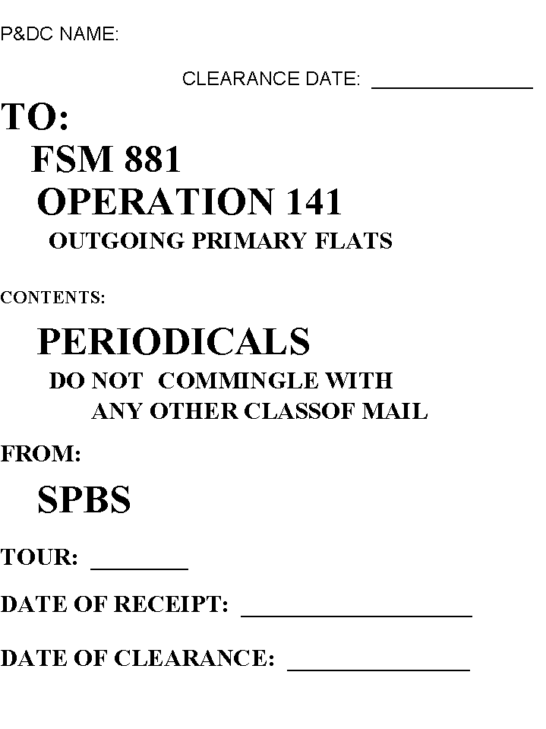

Destination: Dispatch Date: __________________________
ADC MID FLORIDA FL 327
via: Amtrak 327
ROUTING INFORMATION: (check dispatch used)
[ ] AMT 89, C/O 0600 [TRANSFER @ 321] AMT H89A, LV 0300
[ ] AMT 97, C/O 1425 [TRANSFER @ 321] AMT H97, LV 1150

Date of Receipt: ______________ Service Commitment:_________days
Contents: PERIODICALS

(FUTURE USE)

Bar Code

CIN for Periodical

327- 329
334, 347, 349

* * * * * * * * * * * * * * * * * * * * * * * * * * * * * * * * * * * * * * * * * * * * * * * * * * * * * * * * * * * 8 *
ORIGIN: JAF P&DC NY 101 Prepared By:__________

COMMENTS/IRREGULARITIES:

327
For container make-up irregularities, call Ed Cox at (212) 330-3741 or cc:Mail to COX, EDWARD E

P&DC NAME:

CLEARANCE DATE: _______________

TO:
SPBS
OPERATION ___ ___ ___
OUTGOING PRIMARY PERIODICALS

CONTENTS:

PERIODICALS
DO NOT COMMINGLE WITH
ANY OTHER CLASS OF MAIL

FROM:

SACK SORTER
TOUR: ________

DATE OF RECEIPT: ____________________

DATE OF CLEARANCE: ________________
P&DC NAME:

CLEARANCE DATE: _______________

TO:
FSM 881
OPERATION 141
OUTGOING PRIMARY FLATS

CONTENTS:

PERIODICALS
DO NOT COMMINGLE WITH
ANY OTHER CLASSOF MAIL

FROM:

SPBS

TOUR: ________

DATE OF RECEIPT: ___________________

DATE OF CLEARANCE: _______________

