OCA-T-1
Docket Nos. R2001-2
MC2001-2

DIRECT TESTIMONY
OF
KATHIE J. KLASS

ON BEHALF OF
THE OFFICE OF THE CONSUMER ADVOCATE

Counsel: Shelley S. Dreifuss
Office of the Consumer Advocate
1333 H Street, N.W.
Washington, D.C. 20268-0001
(202) 789-6830; Fax (202) 789-6819
Email: dreifusss@prc.gov

October 29, 2001
TABLE OF CONTENTS
Page
I. STATEMENT OF QUALIFICATIONS 1
II. PURPOSE AND SCOPE OF TESTIMONY 1
III. CLASSIFICATION CHANGES BENEFICIAL TO CONSUMERS 2
IV. NO-FEE FREE ELECTRONIC DELIVERY CONFIRMATION 2
V. LEARNING FROM OFFERING 3
VI. REACTION TO RECENT EVENTS 3
VII. HOLIDAY MEDIA ATTENTION 4
VIII. CONCLUSION 5

DIRECT TESTIMONY
OF
KATHIE J. KLASS

STATEMENT OF QUALIFICATIONS
My name is Kathie J. Klass. I am a Consumer Professional in the Office of the Consumer Advocate (OCA). I began my employment at the Postal Rate Commission on October 9, 2001.
Prior to my employment with the Postal Rate Commission, from November 1993-January 2001, I served as Chief, Consumer Information Division for the National Highway Traffic Safety Administration (NHTSA) at the U.S. Department of Transportation. From January 1990 – November 1993, I was the Executive Vice President of the Fight Back! Foundation for Consumer Education. During the 80’s, I served as Executive Officer of the California Consumer Advisory Council in the California Department of Consumer Affairs. I began my career as Consumer Coordinator for Santa Cruz County Consumer Affairs, in the District Attorney’s Office.
I received my MA in 1975 and my BA in 1973 from California State University at San Jose, San Jose, California.

PURPOSE AND SCOPE OF TESTIMONY
The purpose of my testimony is to support the proposed Suspension of the Fee for Manual Delivery Confirmation Service for Priority Mail.
OCA has a history of supporting the extension of Delivery Confirmation benefits to Priority Mail users. In Docket No. R2000-1, for example, OCA proposed extending the fee-free Electronic Delivery Confirmation Service to individual users of Priority Mail (Initial Brief of the OCA at 211-213, filed September 13, 2000). I commend the Postal Service’s proposal to offer free Manual Delivery Confirmation for the first 16 days of December. It is my hope that this trial proves fruitful for the Postal Service and that the free Manual Delivery Confirmation will be a permanent addition to Priority Mail.

CLASSIFICATION CHANGES BENEFICIAL TO CONSUMERS
Witness O’Hara has testified that the advantages of this proposal may not be fully realized in the upcoming holiday season when free Manual Delivery Confirmation is first introduced. He indicates that the Postal Service may wish to make free Manual Delivery Confirmation available permanently on a seasonal basis (Tr. 2/99 and 157), an idea I endorse. The long-term benefits of a permanent seasonal classification are the possibility of reduced supplemental air transportation expenses (Tr. 2/111) and savings in clerk and carrier overtime (USPS-T-1 at 5).
Counsel for the Postal Service indicated during oral argument that the Postal Service is even considering rolling Manual Delivery Confirmation Service into Priority Mail as is done with Electronic Delivery Confirmation (Tr. 1/12). I strongly endorse a classification of this kind.
I was gratified by Dr. O’Hara’s testimony that he is devoting attention to reducing costs for retail customers (Tr. 2/127). I am hopeful that such reduced costs may result in reduced rates for retail mailers.

NO-FEE FREE ELECTRONIC DELIVERY CONFIRMATION
In Docket No. R2000-1, OCA urged the Postal Service to offer fee-free Electronic Delivery Confirmation to individual users. I give the Postal Service kudos for now making this possible on their website. Individual users who prepare, print and affix a Priority Mail Delivery Confirmation label (see Attachment) will obtain Electronic Delivery Confirmation free of charge (Tr. 2/45; witness O’Hara’s response to interrogatory OCA/USPS-T1-1).
During settlement discussions, OCA asked the Postal Service to consider notifying consumers that even after December 16, 2001, they could still obtain free Delivery Confirmation by printing a label for Priority Mail/Delivery Confirmation at the USPS website. This notice would be incorporated into lobby posters, mail, or whatever media the Postal Service uses to inform the public about the suspension of the Manual Delivery Confirmation fee. I recommend that the Postal Service adopt this suggestion.

LEARNING FROM OFFERING
In my opinion, the trial proposed by the Postal Service provides the consumer with a valued service and offers the Postal Service the opportunity to perform a market analysis while facilitating mail delivery earlier in the heavy holiday mailing season. The Postal Service will have the opportunity to evaluate the public’s response to free Manual Delivery Confirmation with Priority Mail. A marketing study tends to provide consumer predictions about future actions, but this trial will demonstrate consumers’ actual interest in the service.

REACTION TO RECENT EVENTS
In light of recent events and with the new safety challenges the Postal Service is facing, this is an appropriate time to offer a new service to consumers to induce them to mail their holiday packages early. This may allow the Postal Service additional time to screen packages, and, even if mail is delayed because of new procedures, holiday gifts are more likely to arrive in time for the holidays. I support the Postal Service’s proposal to offer free Manual Delivery Confirmation Service during the holiday season to encourage consumers to mail early. I should add, however, that no matter what the outcome of this proceeding, I continue to believe that Manual Delivery Confirmation should be offered free to consumers of Priority Mail.

HOLIDAY MEDIA ATTENTION
As someone who has prepared numerous holiday public relations campaigns, I know that offering this service during the holiday season allows local media to present another angle on their traditional holiday postal stories. From my experience, the offering of free Delivery Confirmation will receive more media attention during the holiday season than it would at any other time of the year. It is important to note that during the holiday season local media typically encourage the mailing of holiday parcels in a timely manner, so all carriers benefit from the added publicity. The media stories promoting early mailing of holiday parcels for the Postal Service also serve as a reminder to consumers to send parcels in timely manner, regardless of the company they choose.
In December, the media look for holiday traditions, which means if the Postal Service introduces free Manual Delivery Confirmation on a permanent seasonal basis to encourage early mailing of holiday packages, consumers will learn to expect the announcement and will be reminded to take advantage of the service.

CONCLUSION
In closing, I support the introduction of free Manual Delivery Confirmation Service for this holiday season. With the current safety challenges the Post Office is facing, the introduction of free Manual Delivery Confirmation may have an additional benefit of encouraging consumers to mail early this year to assure that their holiday gifts arrive on time. I recommend that the Postal Service offer permanent free Manual Delivery Confirmation with Priority Mail year round. At the very least, I urge the Postal Service to offer free Manual Delivery on a permanent seasonal basis.

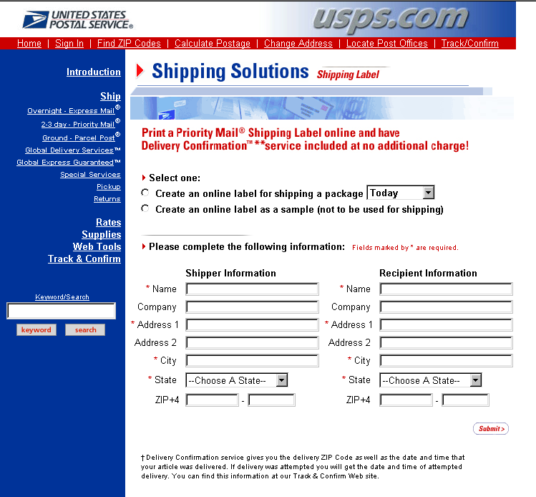USPS-Shipping Label http://www.usps.com/cgi-bin/api/shipping_label.cgi

CERTIFICATE OF SERVICE

I hereby certify that I have this date served the foregoing document upon all participants of record in this proceeding in accordance with Rule 12 of the rules of practice.

h’Enri Whitseyjohnson

Washington, D.C. 20268-0001
October 29, 2001

