UNITED STATES OF AMERICA
POSTAL RATE COMMISSION
WASHINGTON, DC 20268-0001

Postal Rate and Fee Changes Docket No. R2001-1
Experimental Suspension of Fee for Manual Docket No. R2001-2
Delivery Confirmation Category Docket No. MC2001-2
Ride-Along Experiment Extension Docket No. MC2001-3
Complaint of United Parcel Service Docket No. C99-1
Complaint on Sunday and Holiday Collections Docket No. C2001-1
Complaint on First-Class Mail Service Standards Docket No. C2001-3
Filing Online Docket No. RM2001-2

NOTICE TO PARTICIPANTS

(Issued October 24, 2001)

The Commission's Filing Online procedures are sufficiently well developed to warrant commencing a test to determine the feasibility of implementing those procedures formally. Beginning October 25, 2001, the Commission will begin accepting electronic filings in a test docket (T2002-1). The Commission will issue an interim report by mid-November on the testing.
The testing is designed to ensure that the procedures work as intended and that glitches, if any, are eliminated. The Commission is hopeful that Filing Online can be implemented in the near term so that the benefits of electronic filing can be realized. For that to happen, however, the Commission must be satisfied that the procedures work as intended. Thus, to duplicate how the system will function once operational, the Commission encourages all participants to participate actively and fully in testing the Filing Online procedures. All documents, except testimony and briefs, will be accepted in the test docket.
During this test phase, participants are encouraged to sign on, on the same day documents have been filed with the docket section, in the omnibus rate case and other current proceedings and submit those same documents electronically in the test docket. This will allow the Commission and participants to evaluate the new system while assuring that hard copy documents are received and processed. As all documents, both in the pending dockets and the test docket, will appear on the daily listing, participants will be able to check the electronic filings against the hard copy submissions. Due to the volume of filings, all test docket filings may not be posted by the close of business on the day submitted. Electronic submissions will be processed after hard copy filings have been posted. The electronic filing process is described in Attachment A.
To participate in the testing phase, participants should take the following steps:
- Become an Account Holder. (Each person submitting filings should complete and return to the Commission (in hard copy) an Account Holder Application before submitting electronic filings. The Account Holder Application is provided in Attachment B. The application need be submitted only once, provided the information submitted remains unchanged. Each Account Holder will receive a login name and password. The password may be changed upon logging in.)
- Follow the electronic filing instructions set forth in Attachment A. Please note that the main document of each filing must be a PDF file. A conversion function is available.
- Submit electronic documents only under the test docket, Docket No. T2002-1.
Individuals experiencing any electronic filing problems are requested to call the Commission’s Docket Room (at 202-789-6847), or contact the Commission’s webmaster (at webmaster@prc.gov), detailing the problem encountered. In addition, participants are invited to suggest improvements in the Filing Online procedures. As noted above, the Commission anticipates issuing an interim report concerning the testing in the near future with the hope of implementing Filing Online shortly thereafter.

Steven W. Williams
Acting Secretary

eFile/Filing Online

Login Screen
The login screen is accessed from the ‘eFile’ link on the PRC’s banner on the www.prc.gov home page. Users can obtain a username and password by filling out an Account Holder application and filing it with the Commission. An Account Holder application is included with this notice.
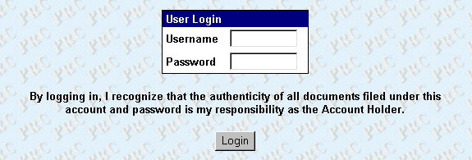
The login screen and the entire Filing Online section of the Commission’s website are secured by Secure Sockets Layer (SSL) protocol. All transmissions between users’ browsers and the Commission’s web server are encrypted.

Welcome Page
Once account holders have successfully logged in, they reach a welcome page that contains simple instructions for using Filing Online.
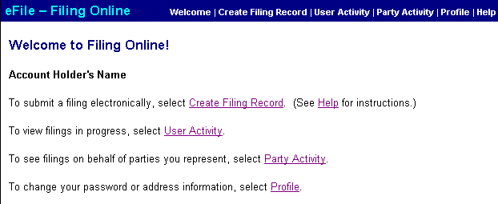

Submitting a Filing
Account Holders can begin the process of submitting a filing by selecting the ‘Create Filing Record’ link to access the entry screen.
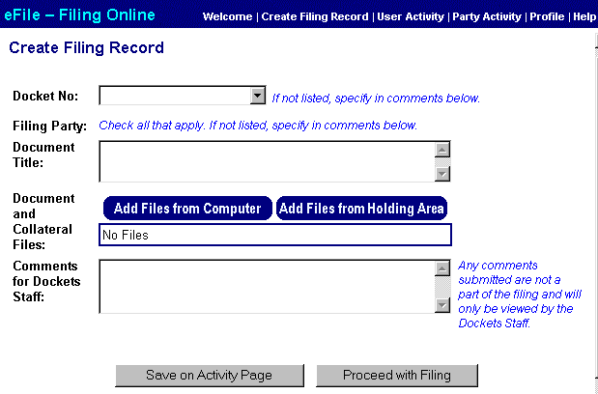
The filing record can be prepared in a few simple steps:
The docket number should be selected from the pull-down list. If the docket number is not listed, enter it in the comments field. During the test phase, pick Docket No. T2002-1, the test docket.
The appropriate filing party should be checked. The list of filing parties generally includes only parties on whose behalf the account holder has previously filed documents. If the appropriate party is not listed, it should be entered in the space for comments. Once the document is filed, that party will be added to the Account Holder's list.
The document title should be entered as it appears on the first page of the filing. It can be cut and pasted from the actual document.
Clicking the 'Add File from Computer' button brings up a screen that allows the Account Holder to attach the electronic file containing the main document and any additional files.
If necessary, the 'Create PDF' button can be used to turn a Postscript, Word, RTF or WordPerfect file into a PDF file. Since the creation of PDFs (with the exception of Postscript) is accomplished by conversion first to a Word 2000 file, some newer versions of WordPerfect may not be supported.
The main document of any filing must be a PDF. Including the original word processing files is optional. Data files may be submitted in their native formats.
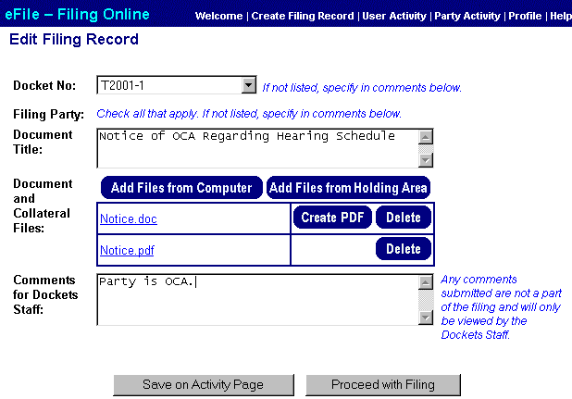
Once all the record information is entered and the document files attached, the Account Holder should click the ‘Proceed with Filing’ button to bring up the confirmation page. The confirmation page gives users a final chance to review the filing before submitting it. Clicking the 'Save on Activity Page' button saves the record on the User Activity page without filing it.
After the Account Holder submits the filing, a receipt page will appear. Users should print this page for their records. The Dockets staff will check the document information and attached files. Assuming these checks reveal no problem, the filing will be made available on the Commission’s website. If there is a problem, the Account Holder will be contacted.

User Activity Page
The User Activity page allows Account Holders to keep track of their electronic filings. It consists of three parts:
Holding Area – The Holding Area is a space for users to upload files they may use more than once or to test the conversion of files to PDF format without creating a filing record. Files in the Holding Area can be added directly to filings using the ‘Add Files from Holding Area’ button. Files remain in the holding area for seven days.
Filings in Progress – Any filings not yet submitted are listed under Filings in Progress. Account Holders can save the filing record and return to them later from this screen. Filings are deleted after seven days.
Submitted Filings – Filings that have been submitted in the last seven days are listed under Submitted Filings. All filings are listed as pending until the Commission’s Dockets staff reviews them.
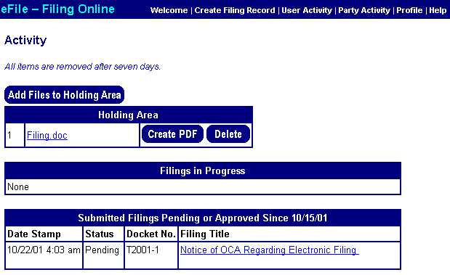

Party Activity Page
The Party Activity page provides a list of all the filings made on that day and the previous business day on behalf of parties the Account Holder represents. Both hard copy and electronic files are listed.

Profile Page
Account Holders can change their password and update their address information on the Profile page. Changing the address information on the profile page will the affect the Account Holder’s address on the Service List and Party Representative pages.

Help Page
Information about using the eFile system is available on the Help page in a question and answer format.
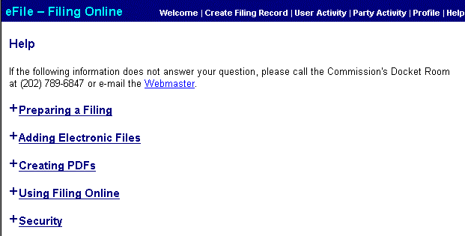

Postal Rate Commission
Filing Online

Account Holder Application

To file documents electronically, each Account Holder must have a login name and password. Upon submitting a completed application to the Commission, the Account Holder will receive a login name and password. The login name/password system is designed to provide an appropriate level of authentication for the types of public, non-proprietary, and non-financial filings permitted under the Commission's rules. Accordingly, each Account Holder is responsible for the authenticity of all documents filed under his/her login name and password. The Commission recognizes that some Account Holders may divulge their login name and password to their support staff for purposes of filing documents with the Commission. Regardless of the procedures followed, the Commission emphasizes that the Account Holder remains accountable for each document filed under his/her account and password. The Commission, therefore, cautions each Account Holder to employ suitable monitoring procedures to ensure that only authentic, authorized filings are made under his/her login name and password.

Account Holder Name
Affiliation
Address
Phone
Fax
Email Address

I, ________________________, recognize that as the Account Holder I remain responsible for the authenticity of all documents filed under my login name and password and undertake to monitor filings with the Commission to safeguard that no unauthorized filing is made under my login name and password.

Signature of Account Holder

