AUTOBIOGRAPHICAL SKETCH
My name is Lloyd B. Raymond. I am President and CEO of Resource & Process Metrics, Inc., a Management Consulting firm specializing in data collection and the development of Engineered Standards (ES). I am a certified Machinist and received a Bachelor of Science in Industrial Engineering from Western New England College.
I have extensive experience applying work-measurement systems, developing time-based planning and scheduling systems, providing data for project/product costing, and making recommendations for methods improvements. I developed work-force management and resource-management systems as a consultant to manufacturing corporations, utility, and telecommunication industries.
I have presented several papers at professional conferences. I also co-authored a chapter in Maynard’s Industrial Engineering Handbook focusing on the special applications of industrial engineering in the utility industry.
In 1997, I founded Resource & Process Metrics, Inc., a company dedicated to the collection of resource utilization data and the creation of metrics to support business decisions. Resource & Process Metrics applies technology to efficiently collect and process information. The data collected becomes the basis for work-measurement application, time-standard establishment, and improved methods recommendations.
The Postal Service contracted with A.T. Kearney and Resource & Process Metrics, Inc. in 1996 to develop engineered methods and time standards for city letter carriers.
For the past three years, I have been applying my knowledge on work-measurement in the Postal industry as Project Manager / Senior Task Order Manager for the Engineered Standards project. While working on this project, I have been studying city letter carriers from an operational, methods-based perspective.
PURPOSE AND SCOPE
At the request the U. S. Postal Service, Resource & Process Metrics, Inc. has supplied Postal Service witness Donald Baron (USPS-T-12) with data collected for the Engineered Standards / Delivery Redesign project. The database for the project contains information pertinent to the study of carrier street activities.
The purpose of my testimony is to define data included in the Engineered Standards database. My testimony should provide the background necessary for the Postal Rate Commission to accept the use of this database as a source of city carrier street activity information.
The Engineered Standards data can be used to support / update current estimates of street-time proportions derived from a Street-Time Survey (STS) conducted over a three-month period in 1986. The Engineered Standards / Delivery Redesign project data were collected from October 1996 through April 1998. The database contains up-to-date information on carrier activity and route characteristics for both office and street.
GUIDE TO TESTIMONY AND SUPPORTING DOCUMENTATION
This submission includes the body of my testimony and an accompanying Library Reference (USPS-LR-I-163, Engineered Standards Database).
Introductory background material is followed by the testimony divided into several sections. Section one details the purpose of the Engineered Standards / Delivery Redesign project and the process of study design. The sections and sub-sections that follow describe phases of data collection. A section discusses data-collection levels and codes as well as work-sampling scan-sequences. A section then outlines quality assurance precautions taken on- and off-site. The final section is a description of the database and steps taken to prepare the data for this case.

Foundational material is provided. Appendices accompany the body of the testimony to facilitate understanding of the Engineered Standards database. The database is provided as Library Reference I-163.
Appendix A: Basic Delivery Hierarchy. A flowchart of carrier activities and route characteristics used to develop barcode methodology.

Appendix B: Data Collection Instruments. Pictures of data collection instruments. The Videx TimeWand II ®(TW2) used by the data collectors to scan barcodes / collect the data (top picture). The Docking Station used to transfer data scanned to on-site computers (bottom picture).

Appendix C: Barcode Scanning Sheets. Barcodes used to collect information. “Header” sheets and outside / street work-sampling sheets are included for reference. Shows how Levels and Codes relate to barcode and data-collection process.

Appendix D: Table of Outside / Street Levels and Codes. Information appearing in columns and rows of database, respectively. Included to clarify the type of information included in each level. For each work-sampling observation, a code combination across levels creates a scan sequence which ultimately appears as a row in the ES database.

Appendix E: Form 3999x. Postal Service Form which contains route information used to prepare database for Foster Associates, Inc.

Appendix F: STS Scan Combinations. According to STS definitions, the grouping of barcode scans used to create the STS data set.

Library Reference: Engineered Standards Database. Outside / Street work-sampling data collected for the Engineered Standards / Delivery Redesign project. A hard copy and/or electronic version are provided.

BODY OF TESTIMONY

I. Project Objective
The objective of the Engineered Standards was to collect actual activities of the city letter carrier and to develop engineered methods and time standards to establish a workload managing system.
To accomplish this task, we required information on the time spent in the office and on the street. Specifically, we needed carrier- and route-based information. We wanted to know what carriers did, how they did it, and what factors (if any) caused changes in performance. We also wanted to know the mode of travel to/from/on a route Mode of travel: walking, driving, or combination. The delivery-type composition: Residential, Business, Mixed, Curb, Central, NBU and combinations. Delivery-point characteristics such as the type of mailbox, number of obstacles encountered (doors, gates), one- or two-handed delivery slots, the degree of customer interaction, etc.
The data collected needed to be comprehensive in order to support in-depth analysis and validation of work methods. The data also needed to provide activity frequency information to determine the percent time spent doing these activities. Data collection occurred over several stages.
II. Process Design
Stage 1. Stage 1 was a task inventory / pilot study. Stage 1 was conducted at two test sites. The steps outlined were performed by an inventory taskforce. The task force consisted of three Postal Service subject matter experts, the data collectors and project managers. Stage 1 was comprised of the following steps:
- Followed carriers from time of arrival at the station (clock-in) to end of the day (clock-out). Teams also traced routes from start to finish.
- Compiled a list of activities performed / route information and arranged the list into a hierarchy.
- Returned to the stations to follow carriers to insure the hierarchy reflected activities performed / route characteristics.
- Adjusted hierarchy and finalized flow-process charts with a data collection structure. Refer to Appendix A.
After completing steps 1 - 4 which provided study composition details, the technology and methodology for collecting the data was decided.
It was determined that two-person teams would be required to collect the work sampling data. These two-person teams would collect the work-sampling data every six minutes using bar-code technology. The work-sampling data identified the frequency of occurrence of an activity, which translated into the percent of time a carrier spent performing certain activities. Work-sampling was expressed as the percent of observations (i.e. percent the carrier was casing, at a curb delivery point, traveling between a curb delivery point, loading for a loop on a park and loop, etc.).
Stage 2. After the methodology was determined, we began Stage 2 of the project, Preparation and Practice.
Items identified in Stage 1’s inventory were assigned a barcode.
- The Videx TimeWand II® (TW2) Barcode Scanners were programmed to recognize these barcodes. Refer to Appendix B. The TW2 was also programmed to emit an audible tone every six-minutes.
- Barcode scanning sheets were assembled into a Barcode Manual. The manual contained various sections: Header information (i.e., Observer ID, State, Unit, Route, Carrier Classification, Start / End Study, Vehicle Odometer), and Outside work-sampling barcodes. Refer to Appendix C.

The data collection technique and tools were tested at the pilot sites mentioned above in Stage 1. Data collectors were instructed not to assist or impede carriers.

III. Data Collection
Two phases were used to collect the data. The phases are differentiated by the site selection process used and number of days a carrier/route was studied. The specific details about data collection are addressed later in this testimony.
Studies were performed Monday through Saturday. Logistically, data collection teams could travel to the sites on Sunday and setup. Selection of the sites was tasked to the geographic regions as is described in sections to follow. We randomly selected the routes studied within the participating locations.
Phase 1. Phase 1 of data collection was a series of one-day studies. To select Phase 1 sites, Engineering sent requests to the 10 geographic regions asking each region to choose 3 to 5 sites (ZIP codes). In addition to the sites selected by the regions, ES used random-number generation to select cities (randomly from a list of finance numbers) and, then, randomly to select the specific ZIP Codes and routes. Data collection began once arrangements were made at the sites selected.
The data collection teams were divided into A and B shifts. A shift collected data Monday through Wednesday and B shift Thursday through Saturday. These teams observed several routes at sites. Team members periodically rotated within and between shifts.
Each day observers used the computer-generated, random-number sheets to select a route for observation. For one-day studies, teams observed a different route everyday unless a route number appeared twice on the random number sheet.
Phase 2. Phase 2 of data collection was a series of multiple-day studies. To select Phase 2 sites, the Postal Service sent requests to the 10 geographic regions asking for the selection of potential Engineered Standards Implementation test sites. ES was made aware of two conditions the regions were to follow, the potential implementation sites required city carriers and needed to have Delivery Unit Computers (DUC). Ten sites were selected as potential implementation test sites. Routes within these sites were randomly selected using the random-number sheets.
In Phase 2, we observed the same routes for consecutive days to determine product-flow / delivery patterns over extended time periods. Phase 2 study design also allowed the study of different carriers on a route. Multiple-day studies were performed at sites, which had been selected in Phase 1, as well as at potential ES implementation sites.
Teams were once again divided into A and B shifts. A shift collected data Monday through Wednesday and B shift Thursday through Saturday. Team members periodically rotated within and between shifts. At each location, the data collectors used the computer-generated, random-number sheets to select a route for observation.
In both phases of data collection, data collectors used the techniques practiced in Stage 2 at the pilot sites. The observers used the barcode technology developed and followed prescribed collection methods. The procedure of data collection used in phases 1 and 2 is outlined in the next section.
IV. Procedure
This section details the collection procedure and the substance of the work-sampling entries.
In Stage 2, Preparation and Practice, the TW2 was programmed with the data collection hierarchy and to emit an audible tone to notify collectors to collect work-sampling data. The collection of the work-sampling data began with this tone. At the beep, the LCD on the TW2 prompted data collectors with the word/phrase representing each level of the collection hierarchy. Information was required to be collected / scanned at each level of the hierarchy. In general, all sub-level information (detail level) was scanned before the data collector continued the scanning process at the next level.
Each line in the Engineered Standards Outside / Street database represents a work-sampling scan. The levels discussed are column headers. The codes discussed below are entries / database cell.
Levels. The Outside / Street work-sampling hierarchy started at Level 10 and consisted of five levels. Refer to Appendix C.
- Level 10. Location. Indicated where the carrier was when the tone signaled the collection of work-sampling data.
- Level 11.1. Personal or Administrative. Indicated if the subject was taking a break or was involved with union business.
- Level 11.2. Delivery Type. Classified the delivery segments as one of five delivery types: Foot, Curb, Park & Loop, Dismount, Central.
- Level 11.3. Delivery Type Status. Classified the delivery point as Business or Residential / inside or outside delivery.
- Level 11.4. Activity. Classified carrier activity. Refer to Appendix D.
- Level 11.4.1. Activity Detail. Provided additional detail on carrier activity.
Codes. At each level, data collectors had a choice of several codes, one or two letters followed by a two-digit number. For example, in Level 10 (Location) data collectors scanned L codes. The two-digit number provided additional information. For example, L17 was Gas Station. Appendix D details the codes used in each level of the outside work-sampling hierarchy.
It is important to recognize the relationship between the levels and codes. For example, at the Activity Level, F codes, which indicate “Interaction deliveries,” were often followed at the Activity Detail Level by G codes, which described the interaction. The tables below are provided to show how codes combine across levels to make-up scan-sequences.
Examples. The following examples demonstrate a scan sequence that represent the street time activities. These activities are Loading, driving, route-access (FAT) running time, route-access (CAT) running time, collection and street support. The scan sequence becomes a line in the database. The scenarios provided below describe commonly occurring events and how data collectors describe that event with the scan sequence.
- The carrier was standing outside at a personal residence on a porch reaching into the satchel to get some mail on a park & loop section. This would represent Loading.
Level 10 | Level 11.1 | Level 11.2 | Level 11.3 | Level 11.4 | Level 11.4.1
L12 | A00 | WT03 | S04 | J12 | H09
Point of Delivery | N/A | Park & Loop Route | Residential  Outside | Finger @ Delivery | 1-Handed Slam
- The LLV is parked and the carrier is at the back restocking the satchel to carry another loop on a residential street. This would represent Street Support.
Level 10 | Level 11.1 | Level 11.2 | Level 11.3 | Level 11.4 | Level 11.4.1
L09 | A00 | WT03 | S04 | J11 | K01
Park Point | N/A | Park & Loop Route | Residential Outside | Setup | LLV
- The carrier is waiting for a stoplight to change color while walking on a segment of a Park & Loop before proceeding on to the next residential delivery point. This would represent route-access (FAT).
Level 10 | Level 11.1 | Level 11.2 | Level 11.3 | Level 11.4 | Level 11.4.1
L21 | A00 | WT03 | S04 | T05 | H00
Wait while walking | N/A | Park & Loop Route | Residential Outside | Walking | N/A
- Carrier is slowing down the jeep to serve a restaurant’s #2 Curb Box that has the Flag up. This would represent route-access (CAT).
Level 10 | Level 11.1 | Level 11.2 | Level 11.3 | Level 11.4 | Level 11.4.1
L13 | A00 | WT02 | S02 | T02 | K00
On Route | N/A | Curb Route | Business Outside | Travel Between Deliveries | Jeep
- The carrier is reaching through the window of the LLV with mail in hand and is moving the flag down on a #1 rural box to serve a residential customer. This would represent Loading.
Level 10 | Level 11.1 | Level 11.2 | Level 11.3 | Level 11.4 | Level 11.4.1
L12 | A00 | WT02 | S04 | J08 | H06
Point of Delivery | N/A | Curb Route | Residential Outside | Delivery/ Collection | #1 Box
6. The carrier has completed the outside delivery and is walking back to the station. This would represent street support.
Level 10 | Level 11.1 | Level 11.2 | Level 11.3 | Level 11.4 | Level 11.4.1
L13 | A00 | WT01 | S00 | T04 | K10
On Route | N/A | Foot Route | N/A | Return to Unit | Walking Flat
Scan sequences become lines in the Engineered Standards database after undergoing a process of quality assurance.
V. Quality Assurance
On- and off-site quality checks were performed to assure the quality of data collected / scanned.
On-site. Data-collection teams uploaded data from the TW2 to the on-site computers daily via the Docking Station. Data collectors printed daily reports which the team reviewed for accuracy of scans and manual entries. Changes were not made on site; any changes to the data where noted and forwarded to the central database managers. After being reviewed, the data was uploaded to a central database.
Off-Site. Data was re-reviewed at the central database. Database managers ran and reviewed reports daily. Oversights such as time or date errors were corrected. Illogical sequence of scans were investigated by data collectors. Errors unable to be resolved by the team investigation were purged from data set.
Another method of quality assurance was a station-level data set created by combining the route-level information. Data for each route were compared to this composite to identify outliers. Outliers were investigated at the site by the collection teams. Teams notified the central database managers and corrections were made or the data entry was deleted.

VI. The Database
The Engineered Standards Outside / Street Database contains 39, 046 lines of data. Each line contains work-sampling information. The data cover 340 routes at 53 different locations. During Phase 1 of data collection, 106 routes were observed at 32 locations. In Phase 2 of data collection, 234 routes were observed at 22 locations. Over the course of the project, 844 route-days of Street information was collected through one-day and multiple-day studies of routes. Of the 844 route-days observed 100 route-days were studied from sites and routes chosen at random.
STS Preparation. The carrier activity information collected during the ES study was classified according to the STS definitions for carrier activities. Refer to Appendix F. The STS defines: Load Time, Street Support Time, Driving Time, Route/Access (FAT), Route/Access (CAT), and Collection Time.
Each line of the ES database contains a work-sampling scan sequence. The information entered in Level 10 through Level 11.4.1 was used to assign STS definitions to ES data. The scan sequence for each line of the database was reviewed and one of the STS categories was entered. The column “STS Type” contains definitions entered by manual sequence review.
To crosscheck the manual review process, a master list was created of scan sequences. The sequences were grouped according to STS activity. All scan-sequence possibilities for an STS activity were assigned a 1-6 code. An update query was then used to assign the sequences a code in the database. These codes appear in the Library Reference USPS-LR-I-163 with the column header “STS Type.”
Upon completing the processing and review of the database it was copied as a file onto a CD-ROM. Resource & Process Metrics gave this CD to witness Baron, USPS-T-12.

Appendix A:

Appendix B

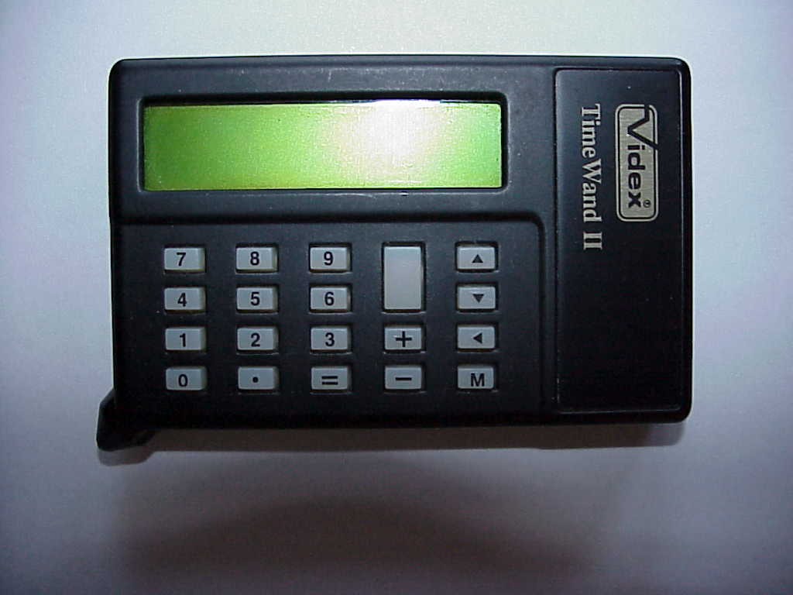

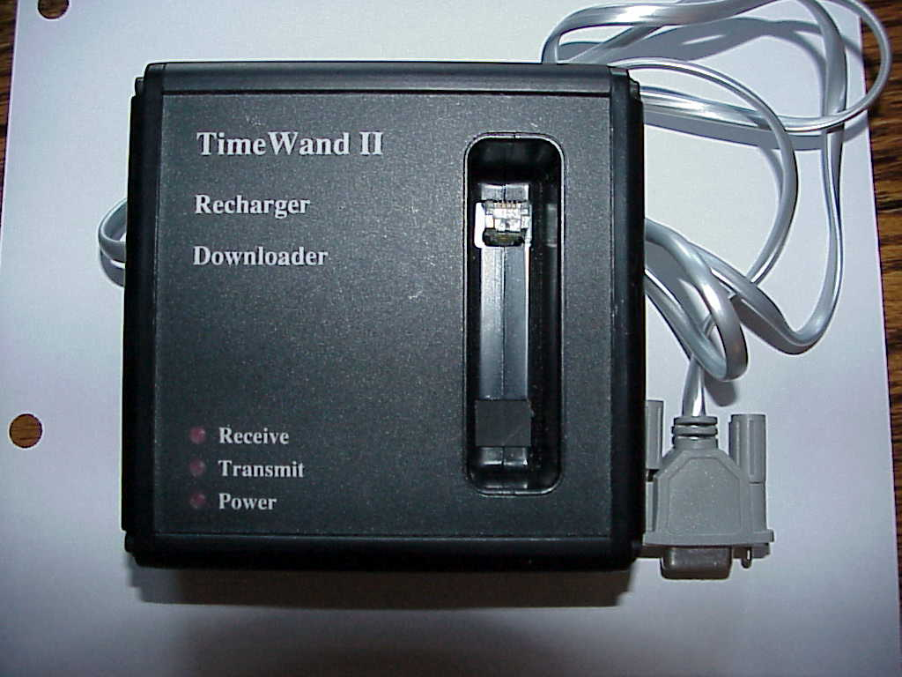

Appendix C

The following is a example of an observers barcode sheet used for the start of day scans and contains levels one through six.
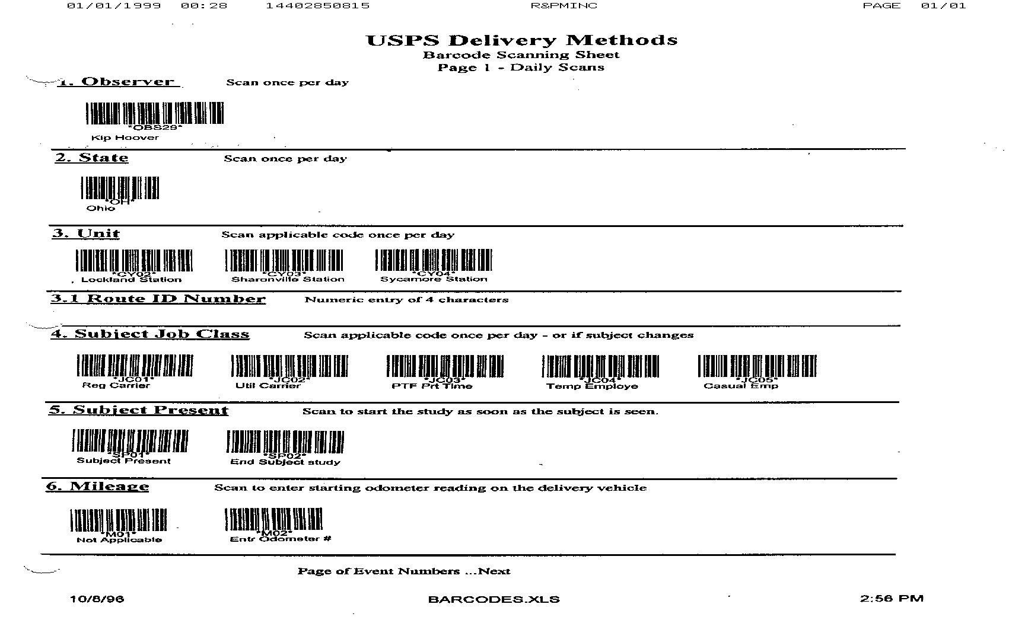

The first four levels of the Street Work Sampling
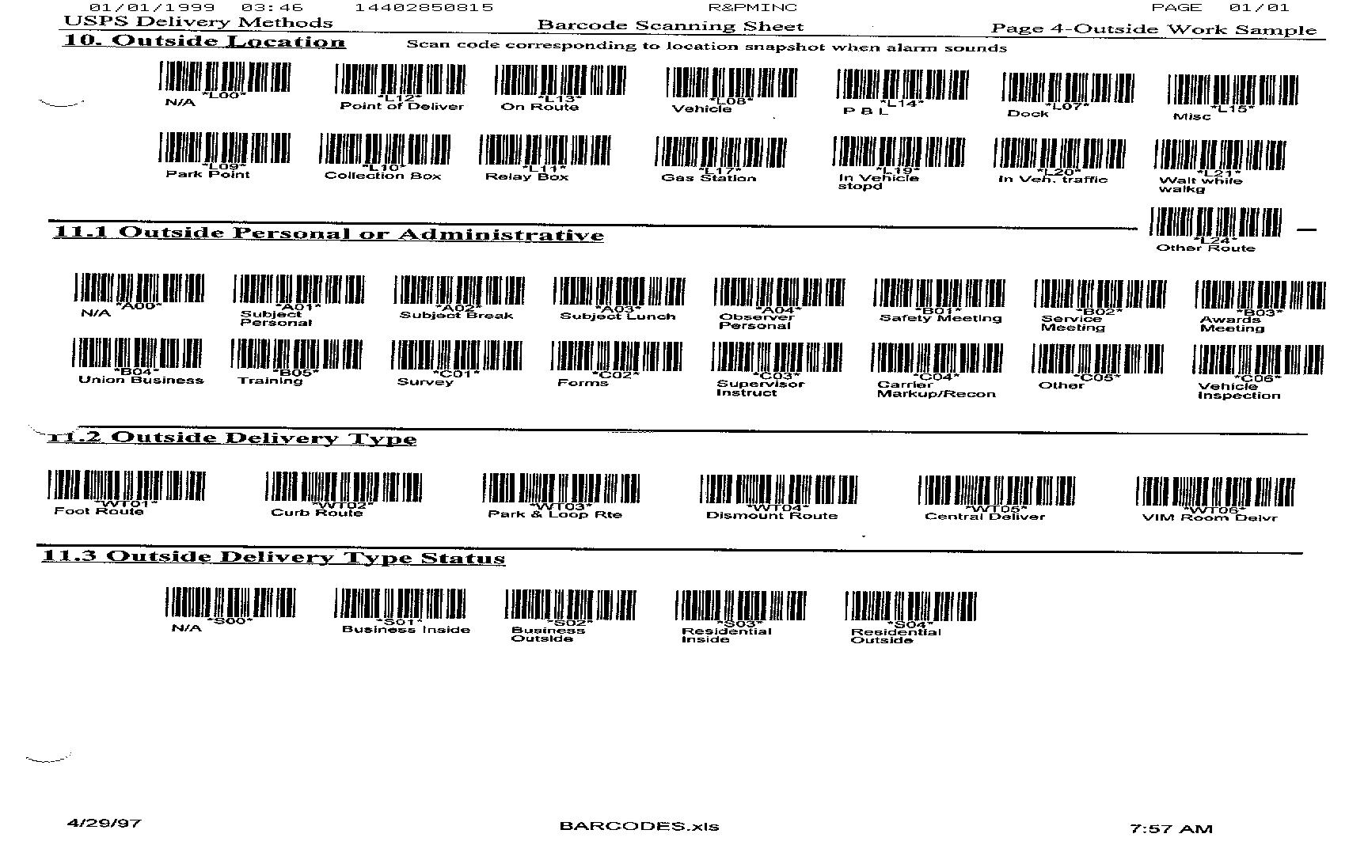
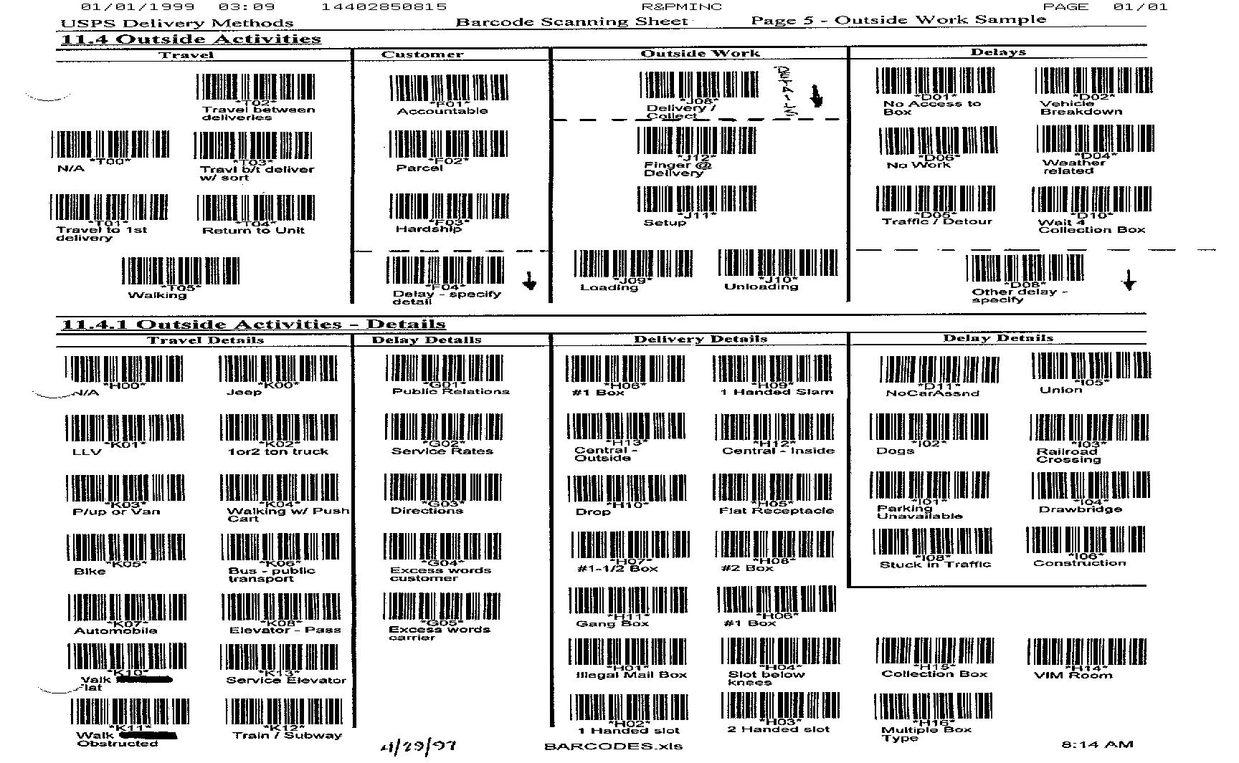
The following are the sub-levels used in work sampling the Street

Appendix D

Level 10 Level 11.1 Level 11.2 Level 11.3 Level 11.4 Level 11.4.1
Code | Location | Code | Personal  Or  Administrative | Code | Delivery  Type | Code | Delivery  Type Status | Code | Activity | Code | Activity  Detail
L00 | N/A | A00 | N/A | WT00 | N/A | S00 | N/A | D01 | No access to Box | E03 | Material Handling
L07 | Dock | A01 | Personal | WT01 | Foot | S01 | Business Inside | D02 | Vehicle Breakdown | G01 | Public Relations
L08 | Vehicle | A02 | Break | WT02 | Curb | S02 | Business Outside | D04 | Weather | G02 | Service Rates
L09 | Park Point | B04 | Union | WT03 | Park & Loop | S03 | Residential Inside | D05 | Traffic/Detour | G03 | Directions
L10 | Collection Box |  |  | WT04 | Dismount | S04 | Residential Outside | D06 | No Work | G04 | Excess Words Customer
L11 | Relay Box |  |  | WT05 | Central |  |  | D08 | Delay - Specify | G05 | Excess Words Carrier
L12 | Point of Delivery |  |  |  |  |  |  | D10 | Wait for Collection | H00 | N/A
L13 | On Route |  |  |  |  |  |  | F01 | Accountable | H01 | Illegal Mail Box
L14 | P B L |  |  |  |  |  |  | F02 | Parcel | H02 | 1-Handed Slot
L15 | Misc. |  |  |  |  |  |  | F03 | Hardship | H03 | 2-Handed Slot
L17 | Gas Station |  |  |  |  |  |  | F04 | Delay - Specify | H04 | Slot below knees
L18 | In Unit walking |  |  |  |  |  |  | J04 | Parcels | H05 | Flat Receptacle
L19 | In Vehicle at Stop |  |  |  |  |  |  | J06 | Mix | H06 | # 1 Box
L20 | In Vehicle in Traffic |  |  |  |  |  |  | J08 | Delivery/Collection | H07 | # 1-1/2 Box
L21 | Wait when Walking |  |  |  |  |  |  | J09 | Loading | H08 | # 2 Box
L24 | Other Route |  |  |  |  |  |  | J10 | Unloading | H09 | 1-Hand Slam
 |  |  |  |  |  |  |  | J11 | Setup | H10 | Drop to Customer
 |  |  |  |  |  |  |  | J12 | Finger @ Delivery | H11 | Gang Box
 |  |  |  |  |  |  |  | T00 | N/A | H12 | Central Inside
 |  |  |  |  |  |  |  | T01 | Travel To 1 Delivery | H13 | Central Outside
 |  |  |  |  |  |  |  | T02 | Travel b/t Delivery | H15 | Collection Box
 |  |  |  |  |  |  |  | T03 | Travel b/t w/sort | H16 | Multiple BoxType
 |  |  |  |  |  |  |  | T04 | Return to Unit | I01 | Parking Unavail.
 |  |  |  |  |  |  |  | T05 | Walking | I02 | Dog
 |  |  |  |  |  |  |  |  |  | I03 | Railroad Xing
 |  |  |  |  |  |  |  |  |  | I05 | Union
 |  |  |  |  |  |  |  |  |  | I06 | Construction
 |  |  |  |  |  |  |  |  |  | I07 | Weather
 |  |  |  |  |  |  |  |  |  | I08 | Stuck in Traffic
 |  |  |  |  |  |  |  |  |  | K00 | Jeep
 |  |  |  |  |  |  |  |  |  | K01 | LLV
 |  |  |  |  |  |  |  |  |  | K02 | 1 or 2 Ton Truck
 |  |  |  |  |  |  |  |  |  | K03 | Pickup / Van
 |  |  |  |  |  |  |  |  |  | K04 | Walk – Push Cart
 |  |  |  |  |  |  |  |  |  | K06 | Bus – Public
 |  |  |  |  |  |  |  |  |  | K07 | Automobile
 |  |  |  |  |  |  |  |  |  | K08 | Elevator Passenger
 |  |  |  |  |  |  |  |  |  | K09 | Walking
 |  |  |  |  |  |  |  |  |  | K10 | Walk Flat
 |  |  |  |  |  |  |  |  |  | K11 | Walk Obstructed
 |  |  |  |  |  |  |  |  |  | K12 | Train / Subway
 |  |  |  |  |  |  |  |  |  | K13 | Service Elevator

LEVEL 10. LOCATION:
L00 N/A: Not Applicable was used to bypass this level when scanning barcodes
L07 Dock: Loading Dock at the Post Office
L08 Vehicle
L09 Park Point: The point where the vehicle is parked on Park and Loop routes
L10 Collection Box: Boxes located throughout the Postal territory used for mail deposit with
scheduled pickup times.
L11 Relay Boxes: Look like collection boxes but are used on foot routes for relays of cased
mail to be picked up by the carrier at the end of each walking loop.
L12 Point of Delivery
L13 On Route
L14 PBL: P, a personal location (i.e. going to the bathroom, Doctors Office, Home); B,
taking an authorized break; and L, at a location for lunch
L15 Miscellaneous
L17 Gas Station: At a gas station servicing the vehicle
L18 In Unit walking
L19 In Vehicle at stop
L20 In Vehicle in Traffic
L21 Wait when Walking (i.e. waiting for an elevator, at a traffic light)
L24 Other Route (i.e. carrier casing another route, delivering another route)

LEVEL 11.1. PERSONAL OR ADMINISTRATIVE:
A00 N/A: Not Applicable was used to bypass this level when scanning barcodes
A01 Personal: Bathroom, Personal phone call, Doctors, Density
A02 Break: Official Breaks
B04 Union: Union Business

LEVEL 11.2. DELIVERY TYPE:
WT00 N/A: Not Applicable was used to bypass this level when scanning barcodes
WT01 Foot: Used on foot walkout routes or foot routes that used public transportation and
relay boxes to acquire their mail
WT02 Curb: Mounted delivery with mailboxes located at curbside and serviceable from inside
the vehicle
WT03 Park and Loop: The use of mounted delivery with restocking of a satchel and customers
served from walking loops with restocking the arm and hand from the satchel.
WT04 Dismount: Serving one or more customers by dismounting and without use of a satchel
WT05 Central: Front, Top, or Back loading boxes accessed by a key opening a door that serve
multiple customers, typically located inside for apartments and outside for neighborhood
distribution centers

LEVEL 11.3. DELIVERY TYPE STATUS
S00 N/A: Not Applicable was used to bypass this level when scanning barcodes
S01 Business Inside: Serves to give additional information as to the type of delivery
S02 Business Outside: Serves to give additional information as to the type of delivery
S03 Residential Inside: Serves to give additional information as to the type of delivery
S04 Residential Outside: Serves to give additional information as to the type of delivery

LEVEL 11.4. ACTIVITY:
T00 N/A: Not Applicable was used to bypass this level when scanning barcodes
LEVEL 11.4.1. ACTIVITY DETAIL:
H00 N/A: Not Applicable was used to bypass this level when scanning barcodes

11.4 and 11.4.1 were scanned as a pair:
“Ts” identifying traveling were paired with Level 11.4.1“Ks” which identify the mode of travel (i.e. T01, Travel to first delivery point with a K01, LLV Long Life Vehicle).

LEVEL 11.4 ACTIVITY | LEVEL 11.4.1 ACTIVITY DETAIL
T01 Travel to first delivery point on route | K00 Jeep: Vehicle used to transport mail
T02 Travel b/t Delivery: Traveling between delivery points | K01 LLV: Long Life Truck used to transport mail
T03 Travel b/t w/Sort: Traveling between delivery points and simultaneously fingering and/or sorting the mail for deposit | K02 1 or 2 Ton Truck
T04 Return To Unit: Traveling back to the Post Office | K03 Pickup / Van: Pickup or Van
T05 Walking | K04 Walk Push Cart: Walking Pushing a cart that is used to transport mail
 | K06 Bus / Public: Using a public bus as transportation
 | K07 Automobile: Used to transport mail – contract vehicle (personal car)
 | K08 Elevator Passenger
 | K09 Walking
 | K10 Walking Flat
 | K11 Walking Obstructed – hills, snow, wet leaves
 | K12 Train/Subway to go to/come from the route
 | K13 Service Elevator
Level 11.4 “Ds” identified delays that were associated with the travel or on route and were typically paired with Level 11.4.1 “Is” (i.e. D05, Traffic/Detour with I06, Construction)

LEVEL 11.4 ACTIVITY | LEVEL 11.4.1 ACTIVITY DETAIL
D01 No access to box | I01 Parking Unavailable
D02 Vehicle Breakdown | I02 Dog
D04 Weather – Duck a tornado, | I03 Railroad Crossing
D05 Traffic/Detour | I05 Union
D06 No Work | I06 Construction
D08 Delay Specify - (write in log) | I07 Weather
D10 Wait for Collection (can not pick up before scheduled time) | I08 Stuck in Traffic
Level 11.4 “Js” identified delivery that were associated activities on route and were typically paired with Level 11.4.1“Hs” (i.e. J12, Finger at Delivery with H12, Central Inside)

LEVEL 11.4 ACTIVITY | LEVEL 11.4.1 ACTIVITY DETAIL
J04 Parcels | H01 Illegal Mail Box: Too high / low, configuration, location
J06 Mix – Letters, Flats, ADVOs - packet | H02 1 Handed Slot: “One hand” can be used to put the mail through the slot
J08 Delivery/Collection: The process of inserting mail and/or picking up mail | H03 2 Handed Slot: “Two handed slot” requires the carrier to hold the mail slot open with one hand and deposit the mail with the other hand.
J09 Loading: Putting mail into vehicle | H04 Slot below the knees: The mail slot is located so low the carrier must reach below the knees to insert the mail
J10 Unloading: Taking empty trays, tubs, collected mail etc out of vehicle typically at the end of day | H05 Flat Receptacle: Typically, two curled metal straps that accept rolled newspapers and flats outside of the mailbox
J11 Setup: Relocating mail form rear of vehicle to front, loading satchel | H06 #1 Box: The smallest sized Rural mailbox (typically the most common curb box)
J12 Finger @ Delivery – the carrier is at the point of delivery and is fingering through the mail to verify the address is correct and collecting the mail to deposit | H07 #1 ½ Box: The mid-sized Rural mailbox
 | H08 # 2 Box: The largest Rural mailbox
 | H09 1-Hand Slam: “One hand slam” delivery based on a flip-top type mailbox. The carrier delivers the mail to the box with a motion using one hand. In the reach to the box, the carriers’ first motion is to open the box with a backhand flip upward then deposits the mail with a slam-dunking downward motion
 | H10 Drop to Customer: Refers to the carrier leaving the mail on a business counter or handing the mail to the customer
 | H11 Gang Box: A grouping of Rural mailboxes mounted side by side and sometimes in two rows. Commonly seen setups for mobile home parks.
 | H12 Central Inside
 | H13 Central Outside
 | H15 Collection Box
 | H16 Multiple Box Type: One address with multiple customer-names and slots for mail.

Level 11.4 “Fs” typically identified deliveries that required customer interaction on route and were typically paired with Level 11.4.1“Gs” (i.e. F03, Hardship with G04, Excess Words Customer)

LEVEL 11.4 ACTIVITY | LEVEL 11.4.1 ACTIVITY DETAIL
F01 Accountable | G01 Public Relations (offering condolence, good luck with, have you seen the new stamps, etc.)
F02 Parcel | G02 Service Rates: Describe a rate for a service
F03 Hardship | G03 Directions: Providing
F04 Delay Specify: Write in log | G04 Excess Words Customer
 | G05 Excess Word Carrier
Appendix E

The following is a cover page of a 3999X set

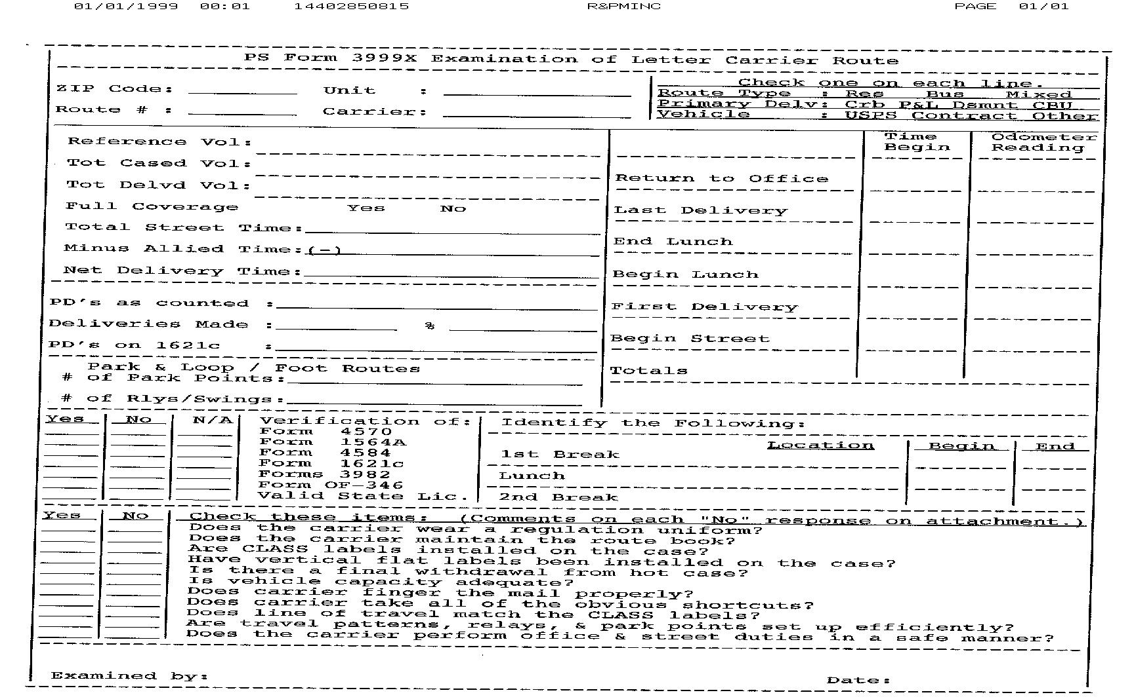
The following is a typical page from a 3999X set.
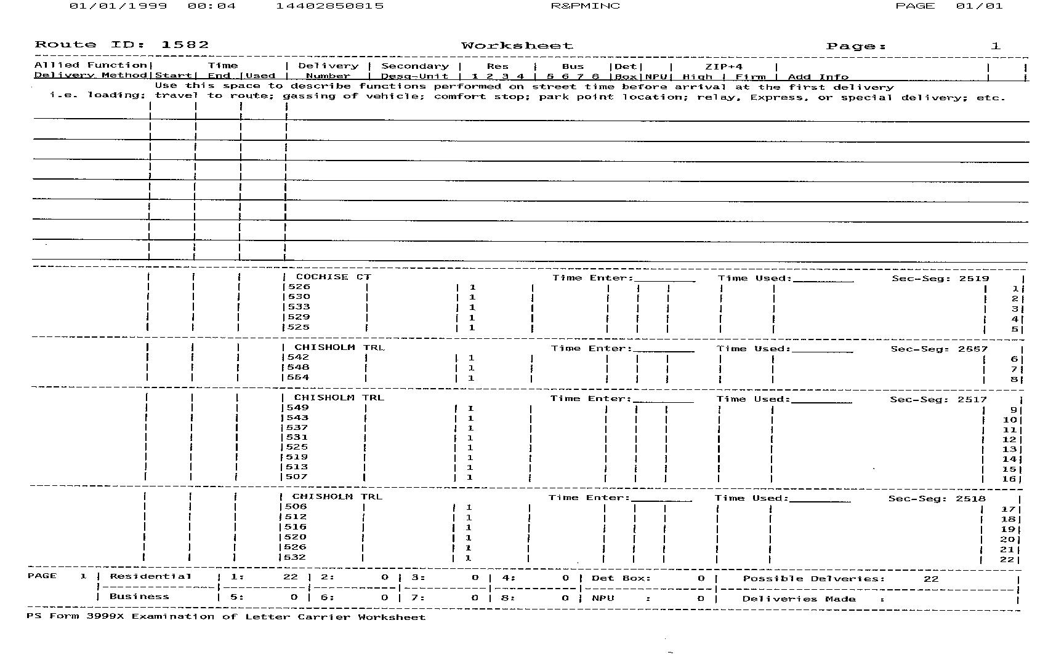

The following is the final page from a 3999X set. ROUTE TOTALS at the bottom of the page were used the steps to classify a route.

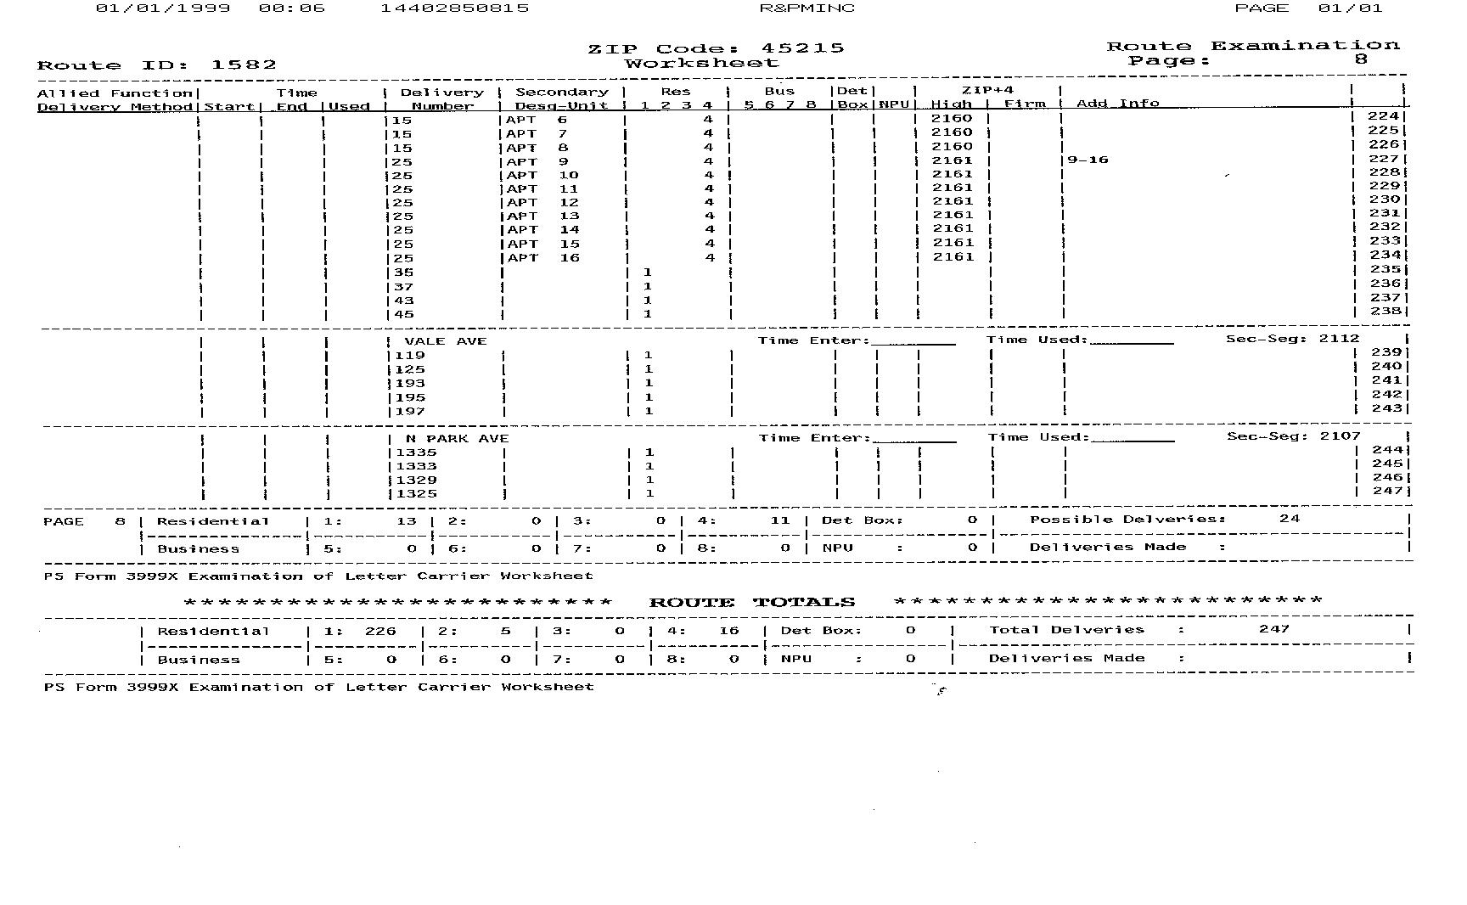

Appendix F

1. Load time: Delivering and collecting mail pieces at residential and business delivery points. Also includes incidental time for customer contacts and the providing of special services.
Levels
10 11.1 11.2 11.3 11.4 11.4.1
Location | Personal &  Administrative | Delivery Type | Delivery Type  Status | Outside Activity | Activity Detail
On Route | N/A | Foot Route | Residential Inside | Delivery/Collection | # 1 Box
Point of Delivery |  | Curb Route | Residential Outside | Parcel | # 1-1/2 Box
Vehicle |  | Park & Loop | Business Inside | Finger @ Delivery | # 2 Box
 |  | Dismount Route | Business Outside | Setup | 1 Hand Slam
 |  | Central Delivery |  |  | 1 Handed Slot
 |  |  |  |  | 2 Handed Slot
 | Forms |  |  | Accountable | Central Inside
 |  |  |  |  | Central Outside
 |  |  |  |  | Directions
 |  |  |  |  | Drop to Customer
 |  |  |  | Delay Specify | Excess Wrds Carr
 |  |  |  |  | Excess Wrds Cust
 |  |  |  |  | Flat Receptacle
 |  |  |  |  | Gang Box
 |  |  |  |  | Illegal Mail Box
 |  |  |  |  | Jeep
 |  |  |  |  | LLV
 |  |  |  |  | Multiple Box Type
 |  |  |  |  | N/A
 |  |  |  |  | Parking Unavailable
 |  |  |  |  | Public Relations
 |  |  |  |  | Service Rates
 |  |  |  |  | Slot below knees
 |  |  |  |  | Walk Flat
 |  |  |  |  | Walk Obstructed
 |  |  |  |  | Walking

2. Street Support time: The part of street time spent on activities such as traveling to and from the route, to the carriers’ station, obtaining and loading the vehicle, and preparing mail in bulk at the vehicle and at relay boxes.
Levels
10 11.1 11.2 11.3 11.4 11.4.1
Location | Personal & Administrative | Delivery Type | Delivery Type  Status | Outside Activity | Activity Detail
Dock | N/A | Foot Route | Residential Inside | Loading | 1 or 2 Ton Track
Gas Station | Subject Break | Curb Route | Residential Outside | Unloading | Automobile
Vehicle | Subject Personal | Park & Loop | Business Inside | Setup | Bus – Public
P B L |  | Dismount Route | Business Outside | Travel to 1st | Central Inside
On Route |  | Central Delivery |  | Return to Unit | Central Outside
Relay Box  Park Point |  |  |  | Delay Specify | Collection Box
Collection Box |  |  |  |  | Directions
Misc. |  |  |  |  | Excess Words Carr
 |  |  |  |  | Jeep
 |  |  |  |  | LLV
 |  |  |  |  | Mat'l Handling
 |  |  |  |  | Multiple Box Type
 |  |  |  |  | N/A
 |  |  |  |  | Parking Unavail
 |  |  |  |  | Pickup / Van
 |  |  |  |  | Public Relations
 |  |  |  |  | Train / Subway
 |  |  |  |  | Union
 |  |  |  |  | Walk Flat
 |  |  |  |  | Walk Obstructed
 |  |  |  |  | Walkg Push Cart
 |  |  |  |  | Walking
3. Driving time: Driving vehicles on all portions of letter routes other than the curbline portions. Also includes time spent driving to stop locations (deviations). It does not include the time spent by the carrier after stopping the vehicle and leaving it.
Levels
10 11.1 11.2 11.3 11.4 11.4.1
Location | Personal & Administrative | Delivery Type | Delivery Type  Status | Outside Activity | Activity Detail
Vehicle | N/A | Foot Route | Residential Inside | Travel between Deliveries | 1 or 2 Ton Track
In Vehicle at stop | Forms | Curb Route | Residential Outside | Traffic/Detour | Automobile
On Route | Supervisor Instruct | Park & Loop | Business Inside | Delay | Bus - Public
Park Point |  | Dismount Route | Business Outside | Vehicle Breakdown | Central Inside
Misc |  | Central Delivery |  | Setup | Construction
 |  |  |  |  | Drop to Customer
 |  |  |  |  | Excess Wrds Cust
 |  |  |  |  | Jeep
 |  |  |  |  | LLV
 |  |  |  |  | N/A
 |  |  |  |  | Pickup / Van
 |  |  |  |  | Railroad Xing
 |  |  |  |  | Stuck in Traffic
 |  |  |  |  | Walkg Push Cart
 |  |  |  |  | Walking
 |  |  |  |  | Weather

4. Route/Access FAT time: The time spent by carriers walking on the foot and park and loop portions of routes. Also includes the time spent accessing stops; that is, walking up to a residential and/or business delivery point to deliver and collect mail pieces.
Levels
10 11.1 11.2 11.3 11.4 11.4.1
Location | Personal &  Administrative | Delivery Type | Delivery Type  Status | Outside Activity | Activity Detail
On Route | N/A | Foot Route | Residential Inside | Travel between deliveries | 1 Handed Slot
Misc |  | Park & Loop | Residential Outside | N/A | Central Inside
Wait while walking |  | Dismount Route | Business Inside | Accountable | Dogs
 |  | Central Delivery | Business Outside | Parcel | Elevator - Passn
 |  |  |  |  | Jeep
 |  |  |  |  | LLV
 |  |  |  |  | Mat'l Handling
 |  |  |  |  | N/A
 |  |  |  |  | Service Elevator
 |  |  |  |  | Walk Flat
 |  |  |  |  | Walk Obstructed
 |  |  |  |  | Walkg Push Cart
 |  |  |  |  | Walking

5. Route/Access CAT time: Vehicle driving time on the curbline portions of routes. Also includes the time spent driving up to curbline stops to load mail into and to collect mail from customer boxes.
Levels
10 11.1 11.2 11.3 11.4 11.4.1
Location | Personal & Administrative | Delivery Type | Delivery Type  Status | Outside Activity | Activity Detail
Vehicle | N/A | Curb | N/A | Travel between Deliveries | 1 or 2 Ton Track
In vehicle at stop |  |  | Residential Outside | Traffic/Detour | Construction
On Route |  |  | Business Outside |  | Dogs
In vehicle traffic |  |  |  | Delay Specify | Jeep
Misc. |  |  |  |  | LLV
 |  |  |  |  | N/A
 |  |  |  |  | Railroad Xing
 |  |  |  |  | Stuck in Traffic
 |  |  |  |  | Walk Flat
 |  |  |  |  | Walk Obstructed
 |  |  |  |  | Weather

6. Collection time: The time spent walking up to and sweeping Express mail and non-Express mail collection boxes. The time spent driving vehicles up to the collection stops is included in Driving Time, as discussed above.
Levels
10 11.1 11.2 11.3 11.4 11.4.1
Location | Personal & Administrative | Delivery Type | Delivery Type  Status | Outside Activity | Activity Detail
Collection box | N/A | N/A | N/A | Deliver/Collect | N/A
 |  | Foot Route | Residential Inside | Setup | Collection box
 |  | Curb Route | Residential Outside | Unloading | Central
 |  | Park & Loop | Business Inside | Wait for collection | Walk flat
 |  | Dismount Route | Business Outside
 |  | Central Delivery

Ciupak, D., & Raymond, L. (1989). Multiple activity analysis: A technique for optimizing the size of utility crews. Societies’ Manufacturing and Productivity Symposium Proceedings (pp. 479-483). Norcross: Industrial Engineering & Management Press. Raymond, L.B. (1986). MOST: A solution to work-measurement in the utility industry. Industrial Engineering Conference Proceedings (pp. 530-533). Norcross: Industrial Engineering & Management Press. Redding, J., & Raymond, L. (1991). New technology for utility work measurement. MOST® User’s Conference Proceedings (pp. 403-423). H.B. Maynard & Company Computer Services Division.
Redding, J., & Raymond, L. (1992). Special industry applications: Utilities. In W.K. Hodson (Ed.), Maynard’s Industrial Engineering Handbook (pp. 15.45-15.61). New York: McGraw-Hill.
The random number generator in Excel® was used to ensure random selection of routes within a station. A computer-generated list of numbers was given to each team. Teams were instructed to start with the first number and scan the list until a number corresponded to an active route. If the route could not be observed, the team scanned the list for the next active route number. Once a route was selected, data was collected from that route for that day.
The Phase 1 one-day studies ranged from10/15/96 to 2/13/97.
Ten sites were selected using random number generation to be observed in addition to sites selected by the regions. One-day studies were performed at eight of these 10 sites.
? The Phase 2 multiple-day studies time frame ranged from 5/5/97 to 4/23/98.
Delivery Redesign reduced the number of implementation test-sites to five.
Multiple-day studies were performed at two of the 10 sites selected by random-number generation in Phase 1. Sixty-two routes were studied for the two sites, a total of 76 days of observations in the data set.
For Outside work-sampling the LCD prompt starts at Level 10, Location.
Each level contained a N/A barcode to enable data collectors to move to the next level unless the data scanned at the level was essential.
One location was observed in both time periods. The total number of different locations for the study is 53.
Route-day breakdown: 237 route-days of information were collected with one-day studies, 607route-days were collected through multiple-day studies.

